**LAB4 - Multiple Linear Regression Using LOOCV**

In this lab, we will perform multiple linear regression with using the leave-one-out cross validation technique. To do this, we will need the .csv provided in the LAB4 folder.

The .csv file is the combination of the two different .csv files in the LAB3 folder. We will perform the same regression as LAB3 (i.e. we will investigate the effects of age, experience and power to the player’s salary), but this time we will perform it multiple times, once for each data point.

(Task 1) You should perform a loop where at each iteration, a different data point is selected as the test data until you select every data point as test data. As you select a data point as test data, you should use the rest as the train data, which are used to calculate the coefficients for the regression. For each iteration, you should compute the MSE (mean squared error). After this loop is finished, you should average all of the MSE values you computed to get the LOOCV estimate for the error.

(Task 2) You should then do the regression one more time, using *all* of the data both as test and train data, and calculate the MSE for this case. You should then print both MSE values (this one, and the one from Task 1) onto the console.

(Task 3) Remember the estimate-error plot you did in the LAB3? Now, you will perform the same plot twice. One plot will be done using the prediction values from Task 1, and the other will be done using the prediction values from Task 2. You can store prediction values from Task 1 inside the aforementioned loop. You plot should look like this: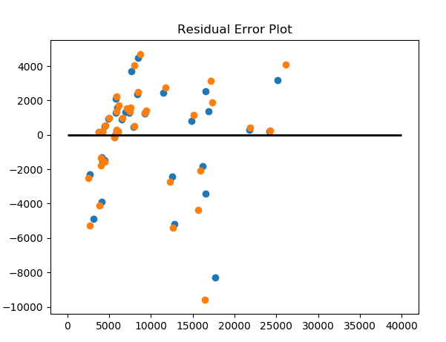

Please use numpy arrays for any numerical arrays or matrices. Similar to the previous labs, we will use matplotlib for plotting purposes. No outside packages are permitted for use except pandas.